In JDBC (Java Database Connectivity), there are three main types of statements used to interact with a database. Each serves a different purpose and is optimized for specific use cases. Here's a breakdown with examples:
1. Statement
- Use Case: Used for general-purpose access to the database. Best for executing static SQL queries without parameters.
- Drawback: Not efficient for repeated queries or dynamic input (can lead to SQL injection).
Example:
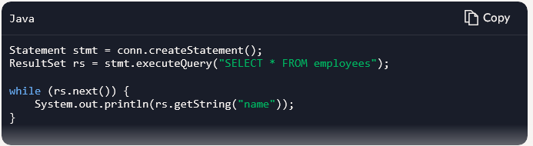
2. PreparedStatement
- Use Case: Used for executing parameterized queries. It’s faster and safer than Statement because it precompiles the SQL and prevents SQL injection.
- Best for: Repeated execution of similar queries with different parameters.
Example:
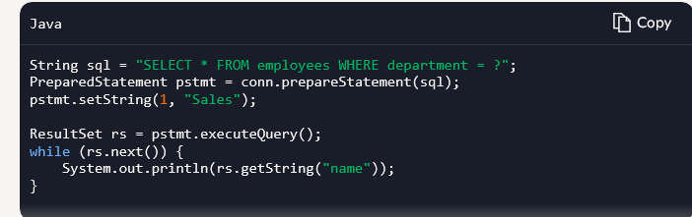
3. CallableStatement
- Use Case: Used to execute stored procedures in the database.
- Best for: Complex operations encapsulated in stored procedures.

Example:
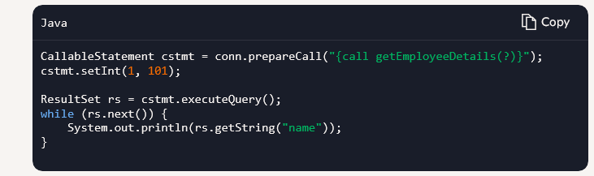
🗃️ Stored Procedure in MySQL
- A Stored Procedure is a precompiled set of SQL statements stored in the database that can be executed as a single unit. It helps improve performance, promotes code reuse, and enhances security by encapsulating logic on the database side.
- A stored procedure is created and stored in the database.
- It can accept input parameters, return output parameters, and execute multiple SQL statements.
- Useful for complex operations like inserting, updating, or retrieving data.
Example: Creating a Stored Procedure in MySQL
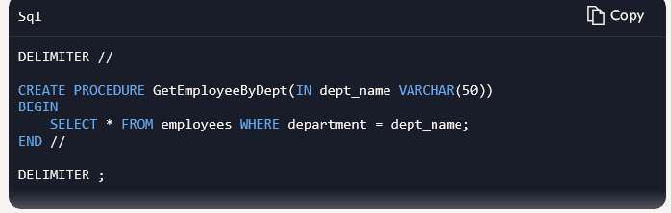
This procedure takes a department name as input and returns all employees in that department.
Calling Stored Procedure in JDBC
- Establish a connection to the database.
- Use CallableStatement to call the stored procedure.
- Set input parameters (if any).
- Execute the procedure and process the result.

Example: Calling the Above Procedure in JDBC

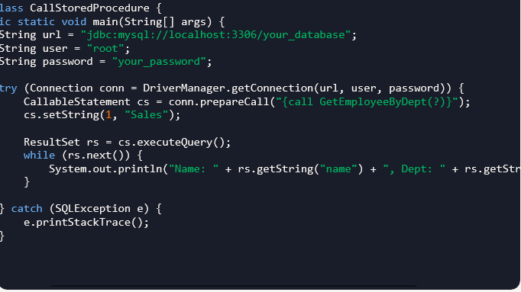
1. MySQL Table Set
CREATE TABLE employees (
id INT AUTO_INCREMENT PRIMARY KEY,
name VARCHAR(50),
salary DECIMAL(10,2)
);
2. Stored Procedures in MySQ
-- INSERT Procedure
DELIMITER //
CREATE PROCEDURE insert_employee(IN emp_name VARCHAR(50), IN emp_salary DECIMAL(10,2))
BEGIN
INSERT INTO employees(name, salary) VALUES(emp_name, emp_salary);
END //
DELIMITER ;

-- UPDATE Procedure
DELIMITER //
CREATE PROCEDURE update_salary(IN emp_id INT, IN new_salary DECIMAL(10,2))
BEGIN
UPDATE employees SET salary = new_salary WHERE id = emp_id;
END //
DELIMITER ;

-- DELETE Procedure
DELIMITER //
CREATE PROCEDURE delete_employee(IN emp_id INT)
BEGIN
DELETE FROM employees WHERE id = emp_id;
END //
DELIMITER ;
import java.sql.*;

public class InsertEmployee {
public static void main(String[] args) {
String url = "jdbc:mysql://localhost:3306/your_db";
String user = "root";
String password = "your_password";

try (Connection conn = DriverManager.getConnection(url, user, password)) {
CallableStatement stmt = conn.prepareCall("{call insert_employee(?, ?)}");
stmt.setString(1, "Kavitha");
stmt.setDouble(2, 55000.00);
stmt.execute();
System.out.println("Employee inserted successfully.");
} catch (SQLException e) {
e.printStackTrace();
}
}
}

import java.sql.*;

public class UpdateSalary {
public static void main(String[] args) {
String url = "jdbc:mysql://localhost:3306/your_db";
String user = "root";
String password = "your_password";

try (Connection conn = DriverManager.getConnection(url, user, password)) {
CallableStatement stmt = conn.prepareCall("{call update_salary(?, ?)}");
stmt.setInt(1, 1); // employee ID
stmt.setDouble(2, 60000.00);
stmt.execute();
System.out.println("Salary updated successfully.");
} catch (SQLException e) {
e.printStackTrace();
}
}
}

import java.sql.*;

public class DeleteEmployee {
public static void main(String[] args) {
String url = "jdbc:mysql://localhost:3306/your_db";
String user = "root";
String password = "your_password";

try (Connection conn = DriverManager.getConnection(url, user, password)) {
CallableStatement stmt = conn.prepareCall("{call delete_employee(?)}");
stmt.setInt(1, 1); // employee ID
stmt.execute();
System.out.println("Employee deleted successfully.");
} catch (SQLException e) {
e.printStackTrace();
}
}
}

Commite and auto commite

public class Democlass {// commite and auto commite
public static void main(String[] args)throws SQLException{
Driver d = new com.mysql.cj.jdbc.Driver();
DriverManager.registerDriver(d);

Connection con = DriverManager.getConnection("jdbc:mysql://localhost: 3306/demojdbc ","root" , "root");
con.setAutoCommit(false);
Statement st = con.createStatement();
// String query = "update demojdbc set salary = 200000 where id = 1 ";
String query = "update demojdbc set salary = 200000 where id = 1 ";
String query1 = "updat demojdbc set salary = 200000 where id = 2 "
int res = st.executeUpdate(query);
System.out.println(res + "rows updated");

int res1 = st.executeUpdate(query1);
System.out.println(res1 + "rows updated");

if(res>0 && res1>0 ) {
con.commit();}
con.close(); }
TRANSACTON HANDLING
public class Democlass {// commite and autocommite
public static void main(String[] args) throws SQLException {
batch();
}
public static void commite()throws SQLException{

Driver d = new com.mysql.cj.jdbc.Driver();
DriverManager.registerDriver(d);

Connection con = DriverManager.getConnection("jdbc:mysql://localhost: 3306/demojdbc ",
"root" , "root");
con.setAutoCommit(false);
Statement st = con.createStatement();
// String query = "update demojdbc set salary = 200000 where id = 1 ";

String query = "update demojdbc set salary = 250000 where id = 1 ";
String query1 = "update demojdbc set salary = 250000 where id = 2 ";

int res = st.executeUpdate(query);
System.out.println(res + "rows updated");

int res1 = st.executeUpdate(query1);
System.out.println(res1 + "rows updated");

if(res>0 && res1>0 ) {
con.commit();
}
con.close();
}

public static void batch() throws SQLException {
Driver d = new com.mysql.cj.jdbc.Driver();
DriverManager.registerDriver(d);

Connection con = DriverManager.getConnection("jdbc:mysql://localhost: 3306/demojdbc ",
"root" , "root");
con.setAutoCommit(false);
Statement st = con.createStatement();

String query = "update demojdbc set salary = 800000 where id = 1 ";
String query1 = "update demojdbc set salary = 380000 where id = 2 ";
String query2 = "update demojdbc set salary = 800000 where id = 3 ";
String query3 = "update demojdbc set salary = 380000 where id = 4 ";
st.addBatch(query);
st.addBatch(query1);
st.addBatch(query2);
st.addBatch(query3);

int[] res = st.executeBatch();

for(int i : res) {
if(i>0) {
continue;
}
else
con.rollback();
}
con.commit();
con.close();
}

}

